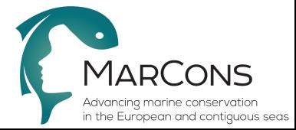

COST Action CA15121
Action Title: Advancing marine conservation in the European and contiguous seas (MarCons)
Draft Agenda
Working Groups 1, 2, 3, 4, 5 Meetings
Zagreb, Croatia
13-14 October 2016

To be completed by the meeting secretary and circulated to the MC and the COST Association (Science and Administrative Officer)

13 October 2016

14:30 Welcome to the participants – logistics – adoption of agenda [Stelios Katsanevakis]

14:45 Overview of the Action – General objectives [Stelios Katsanevakis]

15:00 WG1 presentation in plenary – Discussion [Vanessa Stelzenmüller, Jeroen Steenbeek]

15:20 WG2 presentation in plenary – Discussion [Simonetta Fraschetti, Valentina Todorova]

15:40 WG3 presentation in plenary – Discussion [Vesna Mačić, Paolo Albano]

16:00 Coffee break

16:30 WG4 presentation in plenary – Discussion [Sylvaine Giakoumi, Silvia Carvalho]

16:50 WG5 presentation in plenary – Discussion [Peter Mackelworth, Catarina Grilo]

17:10 Sum up – End of Day 1

14 October 2016

09:00 Split in WGs

11:15 Coffee break

11:45 Split in WGs
13:30 Lunch break

14:30 Split in WGs

15:45 Coffee break

16:15 Meet in plenary – Presentation of progress made by WG leaders

17:00 End of the meeting

