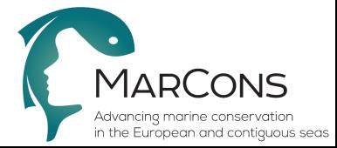

COST Action CA15121
Action Title: Advancing marine conservation in the European and contiguous seas (MarCons)
Draft Agenda
Management Committee Meeting
Zagreb, Croatia
13 October 2016

To be completed by the meeting secretary and circulated to the MC and the COST Association (Science and Administrative Officer)

1. Welcome to participants
2. Verification of the presence of two-thirds of the Participating COST Countries or, if applicable, a
quorum
3. Adoption of agenda
4. Approval of minutes and matters arising of last meeting
- Grant period 1
- Election of vice-leaders of WGs 1 and 4
- Consent to the participation of NNC Institutions
- STSM criteria
5. Update from the Action Chair
a) Status of Action: start and end dates of Action, participating COST countries, participating NNC/
IPC institutions and Specific Organisations.
b) Short Term Scientific Missions (STSM): review of completed reports and new applications
6. Update from the Grant Holder: Action budget status, COST rules for reimbursement
7. Update from the COST Association, if a representative is present
8. Monitoring of the Action
9. Implementation of COST policies on:
a) Promotion of gender balance and Early Career Investigators (ECI)
b) Inclusiveness and Excellence (see below list of Inclusiveness Target Countries)
10. Follow-up of MoU objectives: progress report of working groups
11. Scientific planning
a) Scientific strategy (MoU objectives, GP Goals, WG tasks and deliverables)
b) Action Budget Planning
c) Long-term planning (including anticipated locations and dates of future activities)
d) Dissemination planning (Publications and outreach activities)
12. Requests to join the Action from:
a) COST countries
b) Institutions in Near Neighbouring Countries, International Partner Countries, and/or Specific
Organisations: EU agencies, European RTD Organisation, International Organisations
13. AOB
14. Location and date of next meeting
15. Summary of MC decisions
16. Closing

